|  |  |  |  |
| --- | --- | --- | --- |
| **Telecommunication Development Sector**  **Study Group 2** | | P:\SUP\Logos\Post-150th Anniv\ITU-logo-UNblue.jpg | |
| **Rapporteur Group Meeting for Question 4/2: Telecommunication/ICT equipment: Conformance and interoperability, combating counterfeiting and theft of mobile devices** | | | |
| **Geneva, 10 May 2024** | | | |
|  | |  | |
|  | | **Document 2/68-E** | |
| **10May 2024** | |
| **Original: English** | |
| Question 4/2 |  | |
| SOURCE: | International Telecommunication Academy (Russian Federation) | | |
| TITLE: | New technologies go beyond regulatory and testing procedures | | |
| Necessary actions: | Participants are invited to review this document | | |

*Keywords:Compliance, ITU standards, communication facilities and services*

**Abstract**

For Development beyond regulatory and testing procedures  need One single mechanism. This will achieve the best results in the shortest possible time.

We propose to use PDCA cycle. Such an approach would make it possible to unify development procedures beyond regulatory and testing procedures  and ensure their effectiveness, Integrity and sufficiency.

**Reduce time to market and progressive implementation of rules and procedures for new technologies:**

* **Step 1 :** Use of available testing protocols from equipment manufacturers in conjunction with the analysis procedure;
* **Step 2 :** Deployment of the test area for compatibility testing;
* **Step 3 :**Development of established requirements and testing in an accredited laboratory. New technologies go beyond regulatory and testing procedures

The development of any new technology and the adoption of a new ICT standard always takes time, to establish new regulatory requirements and to organize the testing process.

o solve this problem, we apply a process approach, which is described in the standard ISO 9001. Use the PDCA cycle model (Figure 7.1.1).

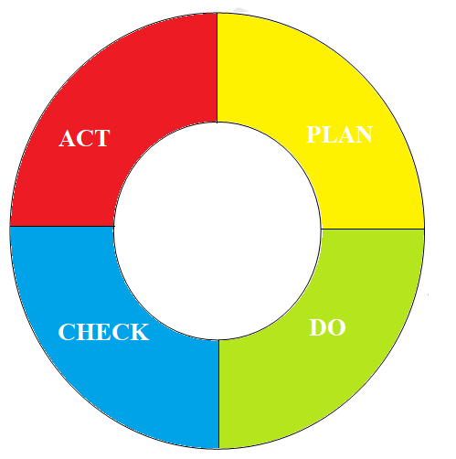

Figure 7.1.1PDCA cycle

**Stage 1 – PLAN.**

At the first stage, it is necessary to plan what new ICT standards should be implemented in the near future. Based on the results of the analysis, a report is drawn up with a list of necessary documents, required to update the current regulatory framework, Setting new requirements and developing methods for testing as part of mandatory conformity assessment and compatibility testing of new equipment(Figure 7.1.2).

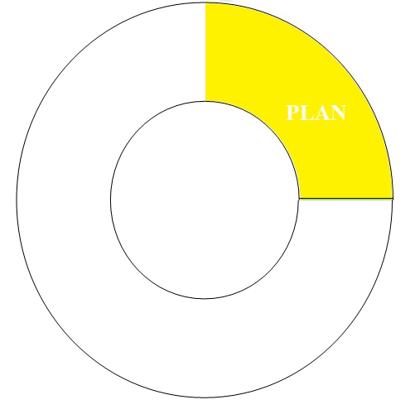

Figure 7.1.2 PLAN stage of PDCA cycle

**Stage 2– Do.**

In the second stage, work is carried out in accordance with the developed regulatory documents, Regulatory Imports, Testing, Installation and maintenance of new ICTs. Monitoring and oversight activities are planned, Comply with and ensure compliance with established requirements. Training and certification of personnel is carried out according to the developed programs(Figure 7.1.3).



Figure 7.1.3 Do stage of PDCA cycle

**Stage 3 – CHECK.**

Analysis of statistics on the use of new ICTs, as well as complaints and wishes of end users, A plan for changes to the current regulatory framework is being developed. Changes are being made and new ICTs are being imported, tested, installed and operated in accordance with the changes. Monitoring and oversight activities are planned, comply with and ensure compliance with the adjusted requirements. Changes to staff training and certification programmes (if required)(Figure 7.1.4).

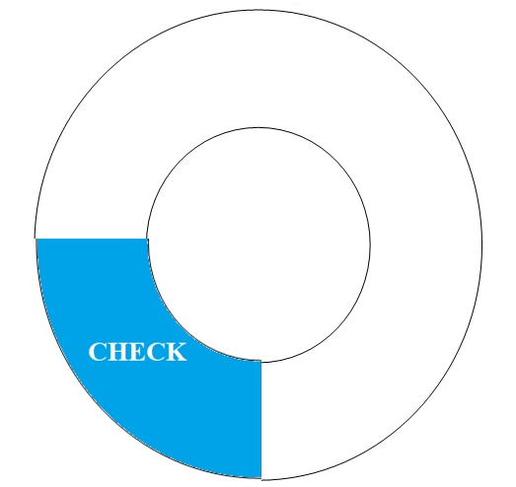

Figure 7.1.4 CHECK stage of PDCA cycle

**Stage 4 – ACT**

he impact of the corrective actions developed in the third phase is reviewed and the prospects for further use of the relevant ICTs are decided. A decision may be made to discontinue the use of(Figure 7.1.5).

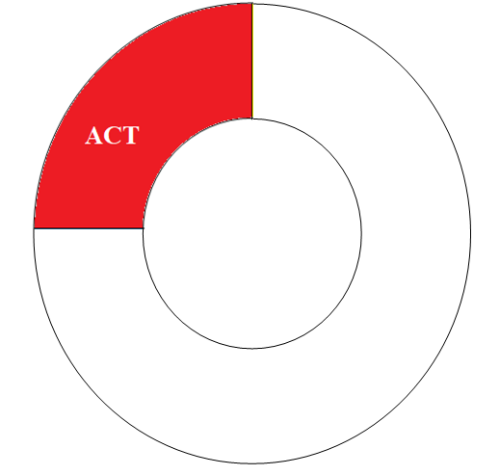

Figure 7.1.3 ACT stage of PDCA cycle

The cycle continues until, No decision has yet been taken to discontinue the use of this ICT, and decommissioning of equipment. It is necessary to develop requirements for safe dismantling., Removal and Disposal of Equipment, As well as training employees, who exploited it...

**Description of the first stage - planning.**

A set of documents should be developed at the planning stage.

Documents must describe

1. Procedure for importing equipment into the territory of the country.
2. Equipment requirements to guarantee safety for people, Animals and the Environment.
3. Equipment requirements to ensure integrity, Sustainability and Security of the Communication Network.
4. Required licences for new ICTs (if required).
5. Procedure for commissioning of equipment for commercial operation.
6. Methods for testing new ICTs as part of mandatory conformity assessment and compatibility testing of new equipment with existing ones on the communication network.
7. Equipment requirements for testing laboratories. Work on accreditation/validation of laboratories for the start of tests using new methods.
8. Training and certification of personnel for design, and testing of new ICTs.
9. Development/addition of control and oversight measures, Guaranteeing compliance with established requirements

All of the above measures require time and material resources. These processes can last for 1-2 years. In order not to slow down the development of ICT in this period, it is advisable to use the examination mechanism.

The Communications Authority gives the authority to the local company, which verifies that the equipment complies with the requirements, Analyzing the manufacturer’s documents. The results of the examination are concluded, On the basis of which the import is made, Installation and Startup of Equipment. This will eliminate obstacles in the deployment of pilot zones and minimize the time of putting the equipment into commercial operation

**Description of the second stage - action.**

Procedures need to be operational during the action phase, which were planned and developed in the previous stage (planning). This requires:

1. To carry out mandatory certification of equipment for compliance with the requirements for ensuring safety for people, Animals and the Environment.
2. To carry out mandatory certification of equipment for compliance with the requirements for the guarantee of integrity, Sustainability and Security of the Communication Network
3. To ensure the import of new ICT equipment in accordance with the developed requirements for the import of this type of equipment.
4. Verify the availability of necessary licenses for the use of new ICTs (if required).
5. Ensure that equipment is put into commercial operation in accordance with the developed requirements.
6. To ensure the work of testing laboratories on new methods.
7. Provide training and certification of personnel for design, and testing of new ICTs.
8. Planning and implementing control and oversight measures, Guaranteeing compliance with established requirements

All activities, ICT-related statistics and end-user complaints are collected.

At the second stage, it is also permissible to use the mechanism of mandatory examination of equipment and projects, When it comes to parameters, Not critical to safety for people, Animals and the Environment.

**Description of the third stage - corrective action.**

In the corrective action phase, statistics and end-user complaints are analysed. Based on this analysis, changes to the following existing processes are planned and implemented:

1. Mandatory certification of equipment for compliance with safety requirements for people, Animals and the Environment.
2. Compulsory certification of equipment for compliance with integrity assurance requirements, Sustainability and Security of the Communication Network
3. Procedure for import of new ICT equipment.
4. Training and certification of personnel for design, and testing of new ICTs.
5. Monitoring and oversight measures, Guaranteeing compliance with established requirements

Based on the results of corrective actions, reports are drawn up and statistical data are formed.

**Description of the fourth stage - decision-making.**

In the decision-making phase, reports and statistics are analysed, previous stage of corrective action.

Based on this analysis, changes to the following existing processes are planned and implemented:

1. Training and certification of personnel for design, and testing of new ICTs.
2. Monitoring and oversight measures, Guaranteeing compliance with established requirements

As a result of a comprehensive analysis of all process data, a decision may be made to discontinue the use of.

|  |  |  |
| --- | --- | --- |
| Contact: | Name/Organization/Entity: | Mr. S.Melnik, Mrs.E.Petrova, International Telecommunication Academy, Prechistenka str, 4, b.2 Moscow, Russian Federation |
|  | Phone number: | +7 916 250 0639 |
|  | E-mail: |  |